IA-2 Organic Solar Cells – Theory and Practice
Name: Pargat Singh Roll. No: 16010121045 Batch: A2 Division: A

Welcome Mail

Quiz Grades

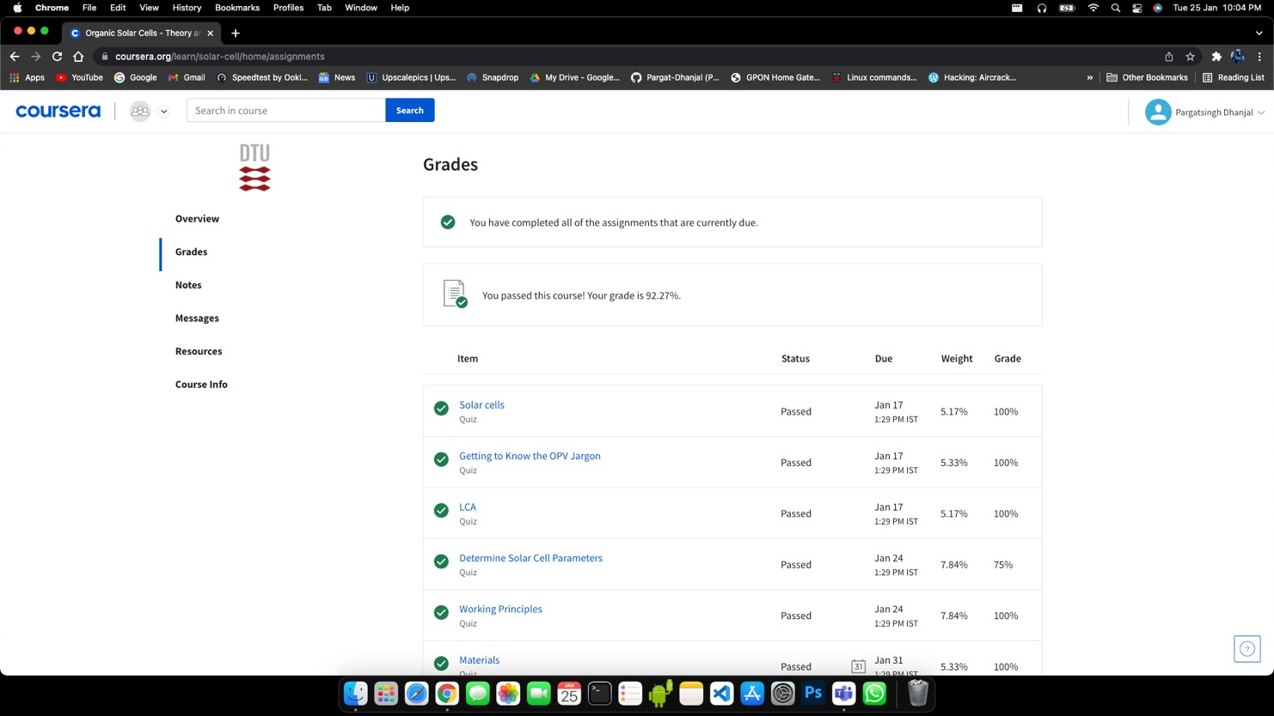
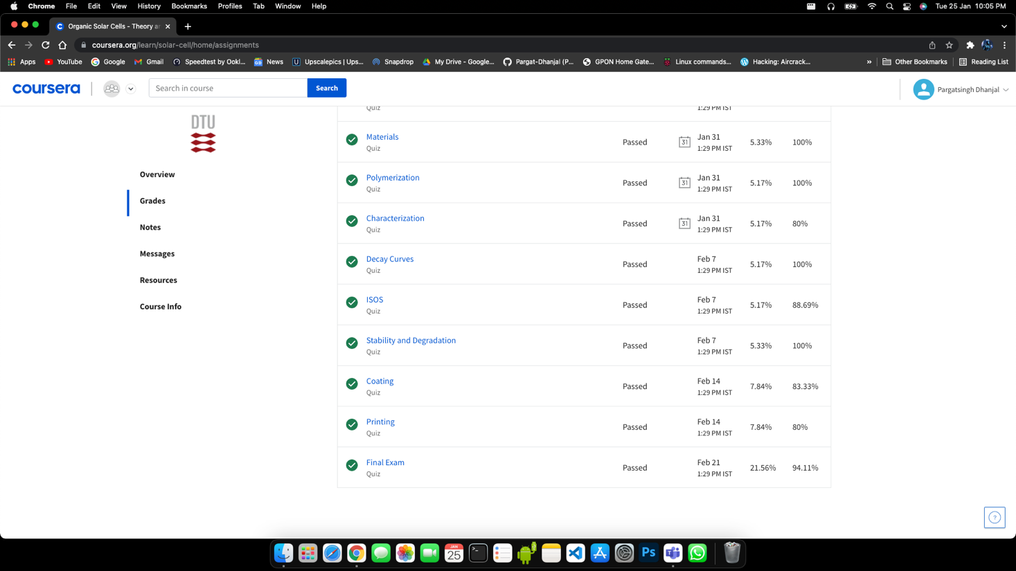

Final Quiz Score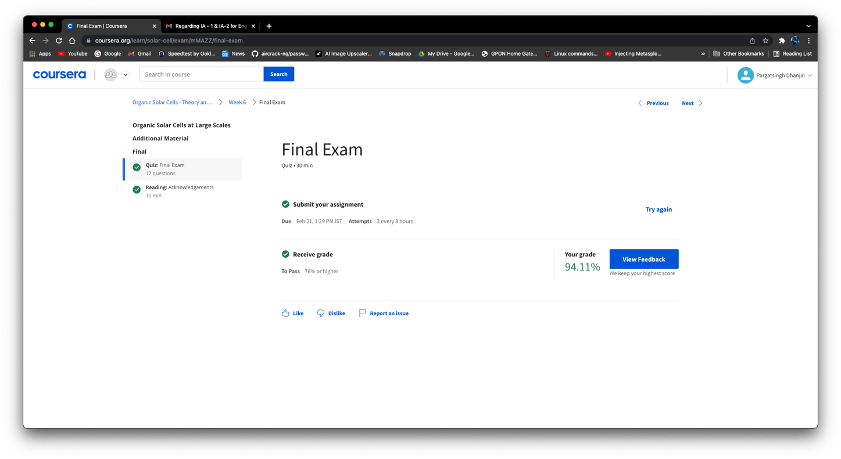
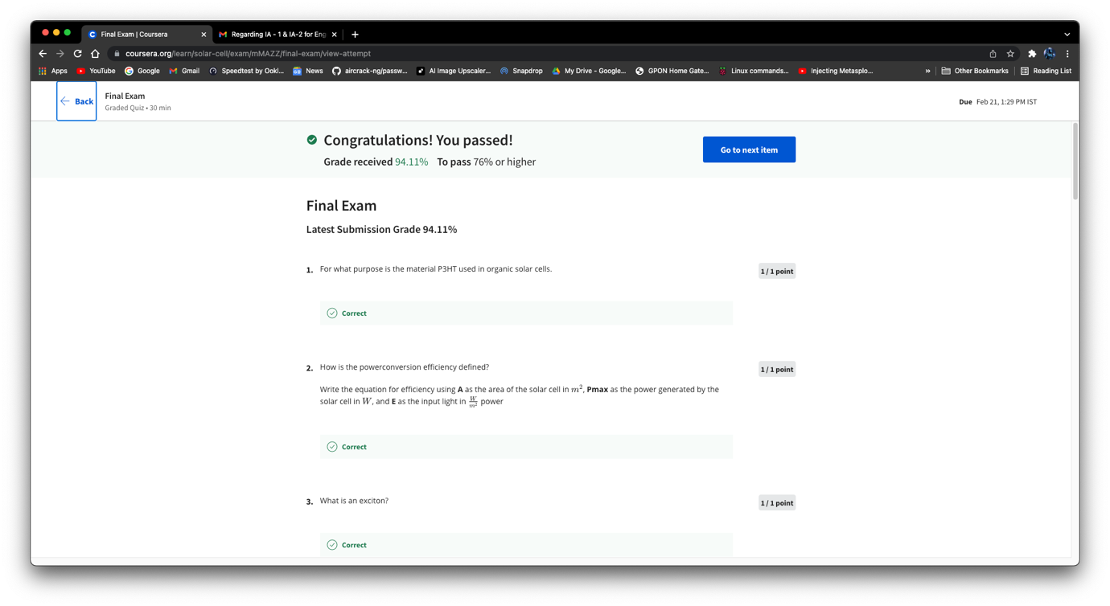
Course Completion Mail



